2.2 I can organise and combine information needed for web pages including across different software

I used Paint for creating my images used for my website and sourced a video from YouTube.

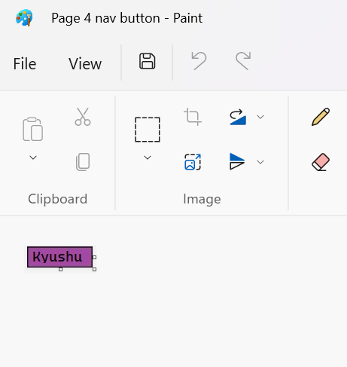

[The above image shows my Kyushu button in Paint and it scaled down to size]

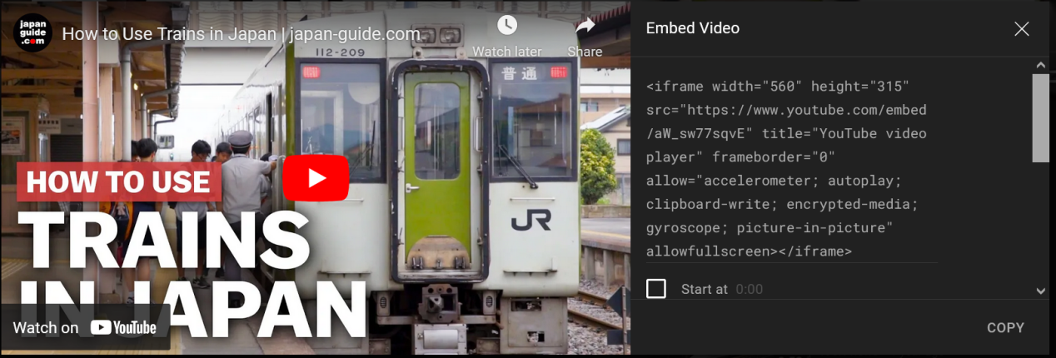

[Above shows me copying the iframe embed code to use it on my web page]

I would like to use software applications such as GIMP, audacity and Inkscape but I would need to a course to learn how to use the applications to a good level in order to produce any good work on there to put onto my web page so I cannot.